Luleå University of Technology

**F70013R Radar for space and atmosphere research 7.5 ECTS**

Assignment: Radar Signal Processing

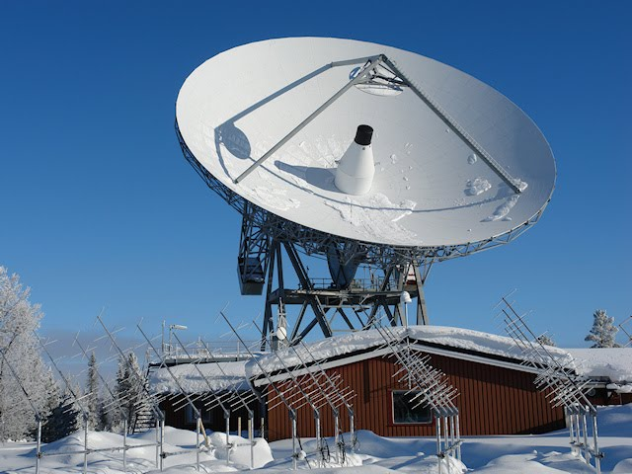

By

Maitreya Ranade

Mini Gupta

Vanshika Kansal



**Kiruna**

**Space Master Program**

**May 16, 2017**